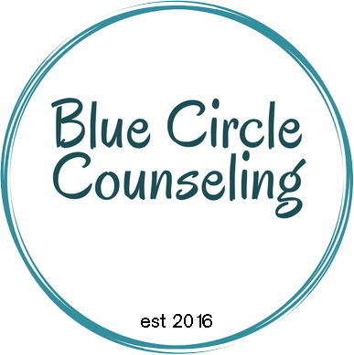
Blue Circle Counseling
counseling·coaching·consulting
Kathy Morgan, M.Ed., LPC, CCST
kathymorgan@bluecirclecounseling.com
www.bluecirclecounseling.com
512-431-1889
CLIENT ___________________________________________________

Person completing this form _____________________________________________ Date____________________

 | Crisis State | Needs Work | Average | Excellent
Acceptable School Behavior
Acceptable School Work
Positive Relationships w/ School Personnel
Positive Relationships w/ Peers
Productive & Peaceful Homework Time
Experiences Joy Regularly
Does Chores w/ 1 reminder
Compliance on 1st request
Utilizes Free Time Independently & Safely
Gets Enough Outdoor Time
Accepts Screen Time Limits
Generally Follows Rules
Positive Relationship w/ Siblings
Positive Relationship w/ Parents/Guardians
Steers Clear of Other’s Business
Participates in Family Games & Outings
Sleep Habits
Eating Habits
Personal Hygiene
Treats Body Appropriately
Accepts Failure Appropriately
Empathic
Thinks of Others
Helps When Asked
Jumps in & Helps When Sees a Need w/o Being Asked
Manages Strong Emotions Well
Is Aware of Needed Growth Areas
Works Through Problems w/o Verbal Aggression
Works Through Problems w/o Physical Aggression
Avoids Sneaky, Manipulative, Revenge Type Behaviors
Displays Appropriate Affect for Situations
Accepts Consequences
Gets to “Shine” in the Family Regularly
Aware of Their Own Strengths & Weaknesses

